**THE MORPHOLIO PROJECT OPENS TO THE PUBLIC ON DECEMBER 15, 2011**

**For Immediate Release**

**New York, December 15, 2011** – The proliferation of device culture, social networking, and cloud technology is changing the way we work and connect on a daily basis. For designers, this means that technology is not only transforming the process of production, but also the

processes through which we share, critique, and organize ourselves around the work we do. It has been predicted that in 2020, there will be 50 billion mobile internet connections worldwide, the equivalent of seven devices per person. Morpholio is not simply about the existence of technology, but rather is a tool for and an experiment in how we might better harness its power.

What is the future of critique, the driver of design culture, in this increasingly connected world? Is the speed at which images circulate around the globe, advancing the level of conversation within and amongst design disciplines? When placed in opposition, the time honored design school tradition of convening public debate around a set of images and ideas, presents a stark contrast to the typical comment forum found in social media. Taken together, however, a new spectrum of valuable means of gathering feedback about one’s work becomes visible. Its continued evolution will be impacted by the tools we create for sustaining and magnifying meaningful conversation, critique, feedback, and debate with a global community.

The Morpholio Project begins by re-imaging the portfolio. “Although essential to design culture, the current methods of creating and sharing design portfolios and presentations still ultimately rely on fixed notions of time, media and outdated technologies of sharing,” says Anna Kenoff, Co-Creator. The design world lacks the tools needed to understand how our work is consumed and experienced by those we most want to reach. The project ultimately asked, what would happen if you could merge processes of presentation, critique and collaboration into a single elastic platform?

PresentCollaborateCritiqueDiagram.eps

In February 2011 a group of five architects, and academics began the experiment with a small collection of collaborators. Software in the form of an app slowly evolved, and in the months following the group quickly expanded to include 50 plus designers as well as members of other visual disciplines such as photographers, artists, and television. Feedback from every user

influenced the process, goals, and definition of the project. “The Morpholio Project is first, and foremost an experiment in distributed intelligence,” says Co-Creator, Mark Collins. “By leveraging the “wisdom of crowds” every designer can see and understand how his or her work is experienced by others”.

Today, The Morpholio Project consists of nearly 200 contributors, now called our Advisory Council, representing a wide range of studios, and universities worldwide including both students and professors from Columbia, Harvard, London’s Architectural Association, and

The School of Visual Arts. In addition, we have recently received the support of Herman Miller, Dyson, and Lutron as sponsors. The software evolves with each new member.

The Morpholio project has ambitious goals. We hope that together with our community we can globalize critique, create a horizontal platform for collaboration and truly reimagine the portfolio as a design utility. Today we are opening the project to the public. **Morpholio Beta 1.0 is now available for download in Apple’s App Store, and accessible via MyMorpholio.com.**

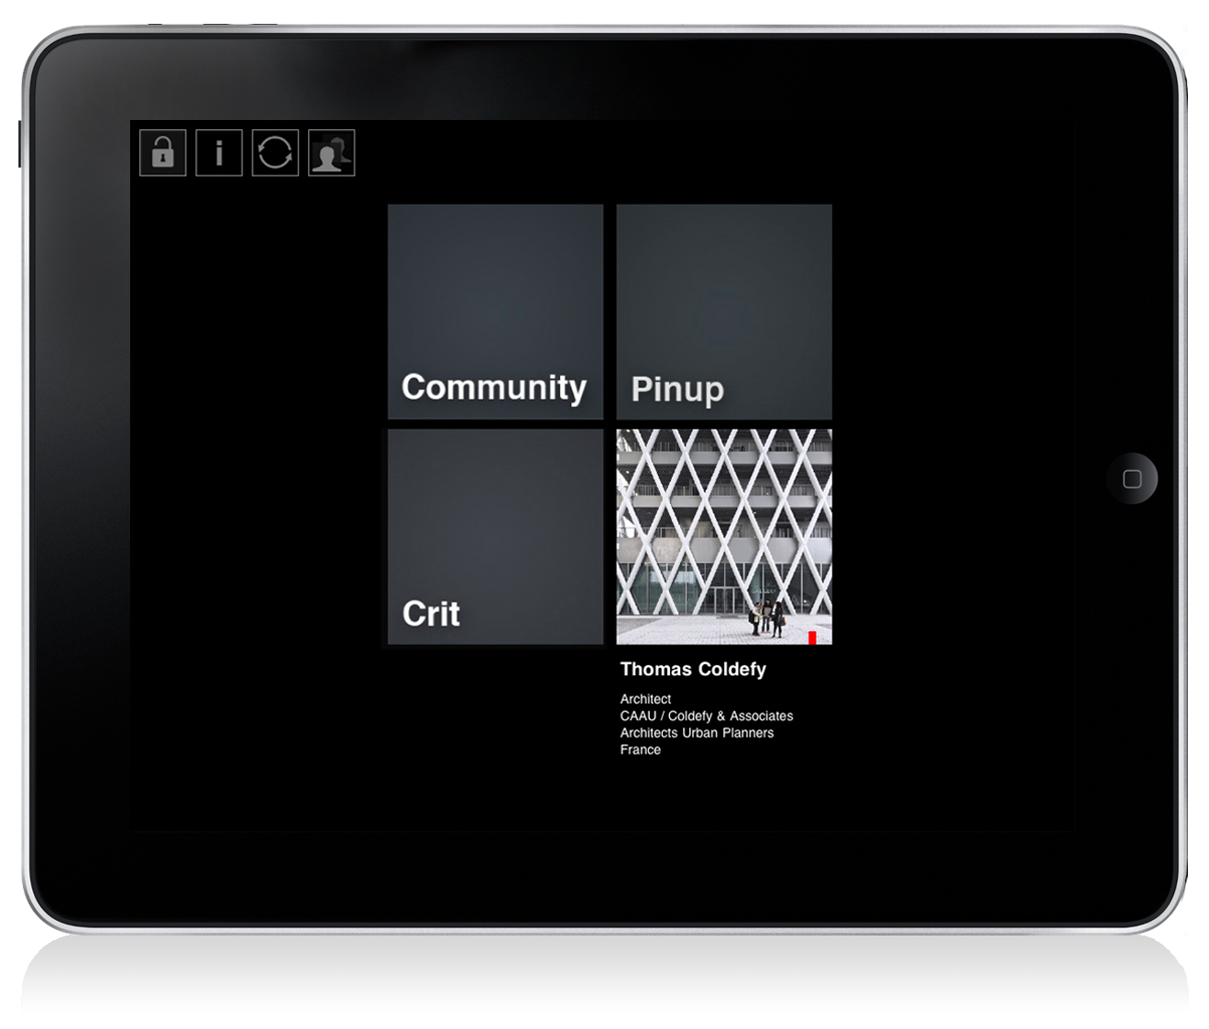

**Morpholio Beta 1.0: Present + Collaborate + Critique**

The iPhone and iPad app, along with the MyMorpholio website, provides a unique space in which to collect, share, and discuss your work.

**Present**

This software begins by transforming the users portfolio into a constantly versioning and customizable collection of images that is more reflective of the way we work today. Capable of communicating with multiple devices, it organizes image collections in a comprehensible and accessible format that makes sharing and presenting work seamless and infinitely flexible.

**Collaborate**

Morpholio "Pinup," allows collections to be posted for invited viewing and response. In "Pinup" you make your work public and searchable by all Morpholio users. You also have the option to send immediate invites to a targeted audience, and continuously update the images they see as you get feedback, and develop ideas. The "Co-creators" feature allows you to share and exchange image collections with anyone you choose, as well as give them access to selected images. Share image collections with your project team, consultants, or collaborators.

**Critique**

Morpholio "Crit" allows collections to be posted for private viewing and response. In "Crit" you can post work and invite other users to critique your work. Invited viewers can easily comment on any image by overlaying text, and will soon be able to use other feedback methods that are currently in development. Set up a critique for your studio, consultants, office, friends or project team.  
  
Morpholio also captures and records other forms of valuable feedback for users. It is currently tracking the amount and type of viewing time, or the "Eye Time" an image receives. This feature collects and constantly updates the most frequently visited, most zoomed, and longest viewed images. "Eye Time" can always be turned on to see how much, and what kind of attention an image is getting, either on this device or on the public network. It tells you how others respond to your work, what drives interest, and where you can improve. Forthcoming features, currently in development, will provide various unique ways of obtaining instant feedback from the many eyes and minds of the Morpholio community.   
  
As this project is still in Beta, graphics and functionality will continue to evolve. We appreciate your patience with any software issues you may encounter and always invite your feedback. Please write to us at community@morpholioapps.com.

**About** (Excerpt from MyMorpholio.com)

Welcome to The Morpholio Project. Founded in 2011, the project began when a group of architects and academics came together to research the ways in which the proliferation of device culture, the development of the cloud, and the ubiquity of social networking, are collectively shaping the creative process.   
  
Morpholio now seeks to create a new platform for presentation, dialogue, and collaboration relevant to all designers, artists and members of any image driven culture. Our interest is in advancing the ways that we discuss, debate, and critique our work with a global community. The mission is to explore ways of harnessing thoughtful feedback about a set of ideas, and to enable members to easily convene meaningful discussion around their work in new kinds of public and private forums.   
  
The project has an Advisory Council of 200 design professionals and artists from various disciplines. It draws representation from a wide range of studios, and universities worldwide including both students and professors from Columbia, Harvard, London’s Architectural Association, MIT, Princeton, and the School of Visual Arts.

**Morpholio was created by:**

Jeffrey Kenoff

Mark Collins

Toru Hasegawa

Anna Kenoff

**Founding Advisory Council Members**

Ahmed ElHusseiny

Aleksandra Sojka

Alkis Klimathianos

Anthony Shung Yiu Ko

Audrey Choi

AYA

Ayaz Momin

Ayesha Husain

BC Albury

Beau Schweikert

Becca Bellamy

Bobby Johnston

Brian Cochran

Brian Thomas

Carmen Cham

Chen Jin

Che-Wei Wang

Chihiro Aoyama

Dan Harding

Daniel Montano Leon

David Andrew Tasman

Esther Sze-Wing Cheung

Ivor Ip

Jaekyung Lee

Jason Causton

James H. Thompson

Kevin Kennedy

LBNYC

Leigh Salem

Leigh Wilkins

Leigha Dennis

Luis Eduardo Carmona

Maider Llaguno Munitxa

Manon Paré

Maoz Price

Mark Bearak

Minyoung Song

Morjuany

Naoki Hirose

Noa Younse

Paul Coughlin

Rachel Lima Villalta

Rafi Segal

Ray Ho

Richard Renfro

Richard Sarrach

Robert Herrick

Ruchicka Modi

Ryan Hughes

Sam Dufaux

Sarah Elaine Smith

Seda Zirek

Shannon Rydell

Shohei Matsukawa

Stanley Formo

Superscript

Tatsuya Sakairi

Thomas Coldefy

Tim Sawyer

Xan Young

Yang Hua

**Sponsors:** Dyson, Herman Miller, Lutron

**Video by:** Ahmed ElHusseiny

**Contributors:** Dan Forest, Noa Younse, Carson Smuts, Robert Johnston, Chou Lien, James H. Thompson, Rafi Segal, Sarah E. Smith, Rebecca Costanzo

**Press Contact:**

Anna Kenoff, 704.517.6147, press@morpholioapps.com

**General Contacts:**

Technical Help: support@morpholioapps.com

Send Feedback: community@morpholioapps.com

Press Inquiries or Partnerships: press@morpholioapps.com

Sponsor or Advertise: sponsor@morpholioapps.com

**For additional press materials and information, please visit: MyMorpholio.com.**